# Help Document for the face reaction detection

Step 1:

* Unzip the “Data” file .
* Open the “face_reaction_detection.sln” solution in the visual studio.

Step 2:

* Add environment
* 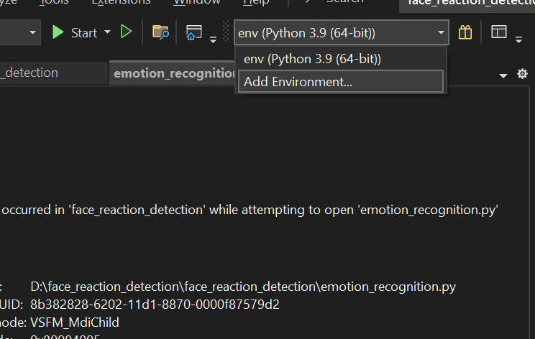
* Create the virtual environment as the below diagram
* A screenshot of a computer

  Description automatically generated
* In the python environment select the “packages(pypi)”
* A screenshot of a computer program

  Description automatically generated
* In the search column install the required libraries
* Copy pastes the names and install that “numpy”, “scikit-learn”,”matplotlib”,”tensorflow”,”pandas”.
* A screenshot of a computer program

  Description automatically generated

Step3[Train the Model]:

* In the solution Explorer Right click the project name and go to properties.
* 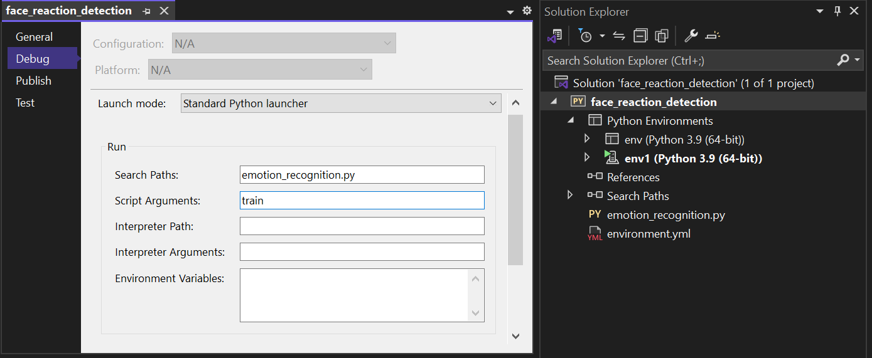
* As the Above fig go to Debug section
* In the search path add the .py file name “emotion_recognition.py”
* In the script arguments enter the text “train” and save.
* Now **Run** the program and wait unit the graph image is visible is show.
* Close the graph.
* Now you can see the build model in the solution folder “model.weights.h5”.

Step4[display the video]:

* In the solution Explorer Right click the project name and go to properties.
* A screenshot of a computer

  Description automatically generated
* As the Above fig go to Debug section
* In the search path add the .py file name “emotion_recognition.py”
* In the script arguments enter the text “display” and save.
* Now **Run** the program.

## Note:

Once you trained the model Don’t need to train the model again and again. train only the data set is changed or updated.